Pout = 8kW, fsw = 1kHz, Vdc = 540V, n = 1









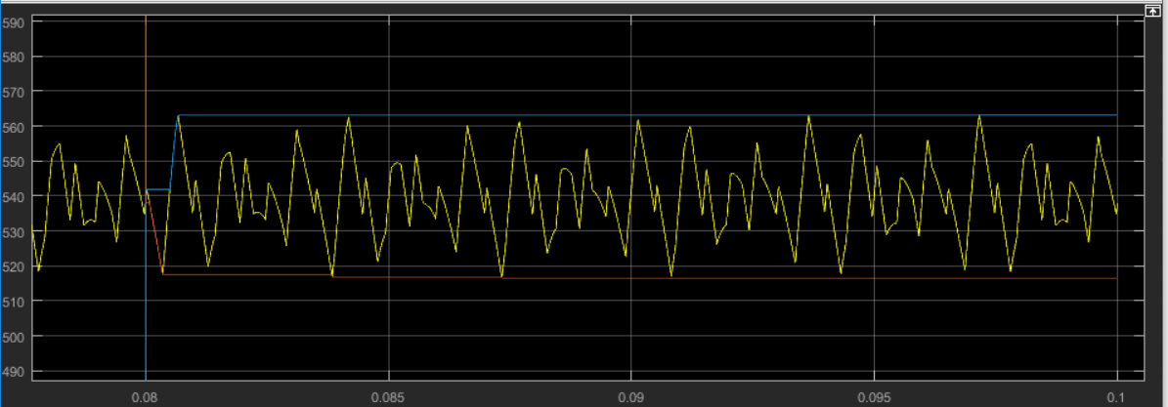

|  |  |  |
| --- | --- | --- |
| **Parameter** | **Simulink** | **Model** |
| DC Link Voltage Ripple (%) | 8.612 | 8.357 |
| DC Link Average Current (A) | 15.78 | 15.76 |
| DC Link Capacitor RMS Current (A) | 10.10 | 10.15 |
| Inverter Phase Voltage Fundamental RMS(V) | 174.1 | 174.2 |
| Inverter Phase Voltage Phase (deg) | 27.07 | 27.11 |
| Inverter Phase Voltage RMS (V) | 270 | 270 |
| Inverter Phase Voltage THD (%) | 118.55 | 118.41 |
| Inverter Line Voltage Fundamental RMS (V) | 301.4 | 301.6 |
| Inverter Phase Voltage Phase (deg) | 57.06 | 57.12 |
| Inverter Phase Voltage RMS (V) | 382.8 | 382.9 |
| Inverter Phase Voltage THD (%) | 78.25 | 78.20 |
| Line Current Fundamental RMS (V) | 18.277 | 18.291 |
| Line Current Phase (deg) | 0.003 | 0.061 |
| Line Current RMS (V) | 18.303 | 18.317 |
| Line Current THD (%) | 5.355 | 5.377 |
| Real Power Output (W) | 8494 | 8504 |
| Power Factor | 0.8902 | 0.8896 |
| Apparent Power (VA) | 9542 | 9559 |

|  |  |
| --- | --- |
| **MATLAB model** | **Simulink** |
|  |  |